Technical Assessment – Architecture

This demo is being applied the Repository pattern design. Because this pattern allows us to test application easily with unit tests. And a Repository Base is referred to as a single transaction that involves multiple insert, update, or delete operations.

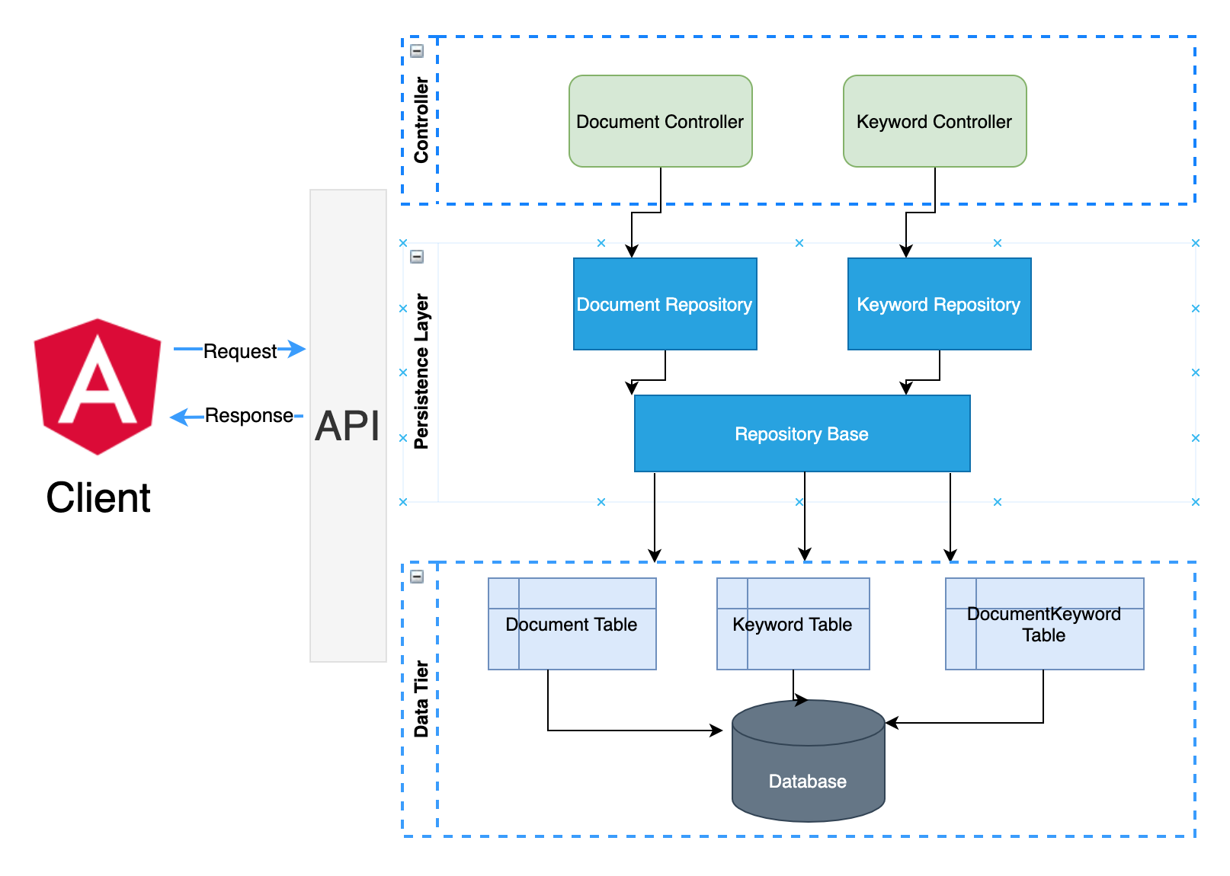

In simple terms, it means that for a specific user action, such as managing keywords on this demo, all the insert, update, and delete operations are handled in a single transaction. This is more efficient than handling multiple database transactions in a chattier way.

About Angular

I used Angular for this assessment because:

1. It’s an open-source front-end framework developed and supported by Google.
2. It helps build interactive and dynamic single page applications (SPAs) with its compelling features including templating, two-way binding, modularization, RESTful API handling, dependency injection, and AJAX handling.
3. In Angular, testing is extremely simple. Angular.js modules has the application parts, which are easy to manipulate.
4. Simplified MVC pattern
5. Reusability

And beside it, I used Ng-Zorro Design is an Angular UI component library which supports 60+ high-quality Angular components out of the box, written in Typescript with complete defined types, high performance and powerful theme customization in every detail.

For more detail, please refer the link: <https://ng.ant.design/components/overview/en>

Assumptions

1. Assumes that the promotional documents are uploaded including some metadata indexes used for mapping and searching such as Product Type, Supplier,…
2. To

Improvement

If I have more time, I will do some improvements such as:

1. Beside adding keyword, allows admin to design more metadata and its data type which would be published to end user to use while uploading file
2. Bases on metadata, admin can set and save a filter as a virtual folders with grouping. When user clicks on the virtual folder, It will show all documents which are matched with conditions.
3. Propose documents based on its content and keyword